Create an HTML form that will look like the following:
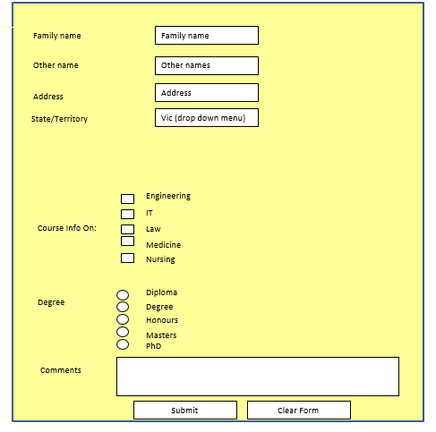
Arrange the six Movies Poster (Images) such as below web page: (Use Figure & figure caption):
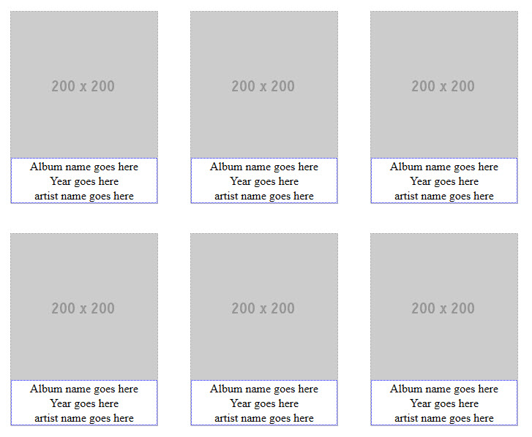
Every image must have Movie Name, Movie Release Date, and Director Name.

